Abstract: Independent Component Analysis requires that the cost function used for separation be robust, consistent and non-quadratic in nature. Given the apparent freedom to choose non-linearites , we propose here to use Cauchy, Huber, Welsch and Geman-Mclure as cost function for FastICA. Simulations are run to compare the algorithms on non-gaussian and real life examples. The separating capability, along with convergence speed and the ability to converge successfully is observed.

A COMPARATIVE ANALYSIS OF M-ESTIMATORS AS A COST FUNCTION FOR FASTICA
Reedip Banerjee¹ and Udayan Ghose ²
¹ University School of Information Technology, Guru Gobind Singh Indraprastha University
Delhi, Delhi, India
reedip14@gmail.com

² University School of Information Technology, Guru Gobind Singh Indraprastha University
Delhi, Delhi, India
g_udayan@lycos.com
Keywords: M-Estimators, FastICA, Negentropy
INTRODUCTION
Given a set of observed signals, we use Blind Source Separation to estimate the actual source signals, whose mixing created the observed set. Blind Source Separation (BSS) has advanced a lot in the past few years with regards to improvising and creating efficient algorithms to application in various fields. Among the various algorithms proposed for BSS, Independent Component Analysis is possibly the most common and known algorithm. Independent Component Analysis (ICA) is a method of decomposing a multiple variable dataset into the set of statistically independent variables which created it.
ICA defines a model for the observed data in which, the observed variables are assumed to be linear mixtures of some unknown source signals, with an unknown mixing system. The source signals are assumed nongaussian, and mutually independent and they are called the independent components of the observed data. These independent components can be found by ICA[1].The only exception to this fact is that ICA allows maximum of one Gaussian signal to exist.
I.ICA
Let us assume that we have an observed signal ‘x’. It is a multidimensional variable, and can be described as
x = [x₁,x₂,x₃,x₄……x_{n} ]
The observed signal is itself a collection of various source signals, each of which is assumed mutually independent, meaning there is no impact on the other signals if one of them experiences any changes. We can hence write the signal ‘x’ as a vector which has been created by the mixing matrix ‘A’ operating on the original independent signals ‘s’:
x(t )= As(t) + Ω -(1)
Ω in (1) is the additional noise present during the recording of observed data. To recover the signal, we estimate the demixing matrix ‘w’. If y is the set of estimated signals recovered by executing ICA on the observed signals, then
y=wx -(2)
II. FastICA
FastICA is a computationally efficient algorithm for Independent component analysis. The algorithm is based on a maximizing non-gaussianity as a measure of statistical independence between the signals. [1,6]
The FastICA has most of the advantages of neural algorithms: It can determine all signals in parallel, it is distributed, computationally simple, and requires little memory space.[4]
Non-Gaussianity can be measured using Kurtosis and Negentropy. However, FastICA algorithm iteratively maximizes an approximate of the negentropy of the observed data. Since, among all variables of equal variance, gaussian variables have the largest entropy; negentropy can be used to define a measure of nongaussianity [3].
As per [2], ICA in itself, and FastICA as its derivative, acts to maximize Negentropy, using the equation,
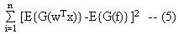
with the constraint that E{(w^{T}x)²}=1, where ‘G’ can be almost any non-quadratic function, ‘f’ a unit-variance Gaussian random variable and ‘x’ an n-variable vector.
Convergence means that the old and new values of w point in the same direction, i.e. their dot-product are nearly equal to 1, maximizing negentropy. It is not necessary that the vector converges to a single point.[5].
The basic form of the FastICA algorithm is as follows:
1. Choose an initial weight vector w.
2. Let w⁺_{i}= E{z_{i}(t)g(w^{T}z_{i}(t))}－E{g(w^{T}z_{i}(t))}w
3. Let w_{i+1} = w⁺_{i}/√(w^{+T}_{i})(w⁺_{i})
4. If not converged, go back to 2.
where z_{i}(t) is the estimated source at time t and iteration i. FastICA assumes that the data, x, has been prewhitened to z_{i}(t) using a linear transformation, to create uncorrelated entries.
Since FastICA is known to be sensitive to its initialization, therefore in our study we have kept the initial weight constant for all the studied samples. FastICA reinitializes the weight if it doesn’t converge.
The algorithm finds independent components of almost any non-Gaussian distribution using any non-linearity g [1,8]. However, like other similar algorithms, the selection of non-linearity g may depend on the probability distribution function (p.d.f) of the original source signal. The only condition for non-linearity g is that it should be a non-quadratic function in nature.[7]
The performance of FastICA can be optimized by choosing a suitable nonlinearity g for specific distributions. However, non-linearites suggested in [7] can cover most signal distributions, though no proof of the same has been given.
2. M-Estimators as Cost Function for FastICA
M-Estimators are a generalized case of Maximum Likelihood Estimators, proposed by Huber.
It was proposed for estimating the likelihood of a variable contained in a normal distribution, which has been effected by outliers. Therefore, given a set of observed data, they are used to estimate the p.d.f which would most likely result in the actual source [6].
Unlike Least Square Method, M-Estimators utilize a cost function ρ (k) to reduce the effect of outliers, thus making it more robust in nature.

It is the shape of ρ (k) which controls the accuracy and robustness of the estimated value. This is because the knowledge about the actual signal is not known.
The derivative Ψ(x) = d ρ (x)/dx is called the influence function. Ψ (x) measures the influence of an observed variable on the value of the estimate.

If the observed variables are a set a(k), 1≤k≤M, then M-Estimators are used to estimate the actual signal a*

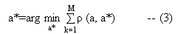
M-Estimators need to minimize (3),and therefore we have
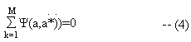
In our study, we consider four M-Estimators as cost function for FastICA [10]
- Huber: The Huber M-Estimator is defined as:
ρ(x) = x²/2 , |x| <= k_{huber}
k_{huber} (|x| - k_{huber} /2) , |x| > k_{huber}
The value k acts as a tuning constant over which the estimation occurs.
The influence function, Ψ(x) is given as
Ψ(x) = x , |x| <=k_{huber}
k_{huber} (sign(x)) , |x| > k_{huber}
Huber’s function has a linear shape above the tuning constant ‘k_{huber}’, but has a parabolic shape below ‘k_{huber}’, in the vicinity of zero.

- Cauchy: The Cauchy’s M-Estimator is defined as:
ρ(x) = c_{k}² (log(1+(x/c_{k})²)/2
Again, the constant ‘c_{k}’ here defines the tuning parameter of the function.
The influence function is given as
Ψ(x) =x/(1+(x/c_{k})²)

- Welsch: The Welsch M-Estimator is defined as :
ρ(x) = c² (1 - exp(x/c)²)/2
The constant ‘c’ here defines the tuning parameter of the function.
The influence function, Ψ(x) is given as
Ψ(x) =x (exp-(x/c)²)

- Geman-McLure: The Geman-McLure M-Estimator is defined as :
ρ(x) = x² /2 (1+x²)
The influence function, Ψ(x) is given as
Ψ(x) = x /(1+x²) ²

These functions can considerably reduce or even eliminate the influence of outliers.

The idea of FastICA supporting almost any cost function for its algorithm amused us to experiment with the set of M-estimator functions as the cost function for FastICA, along with the fact that M-Estimators are very robust against outliers, which is a required property of cost functions for FastICA, as specified in [2].

The advantage of using the influence function of M- Estimators for FastICA Algorithm is that the algorithm becomes simple, using simple multiplication, addition and relational operations.

Also, Huber’s M-Estimator has already been studied in [7] and seems to be a likely candidate as a cost function. Welsch’s M-Estimator is very similar to the practical cost function given in [2], and therefore has been chosen as a candidate as well.

3.Simulations
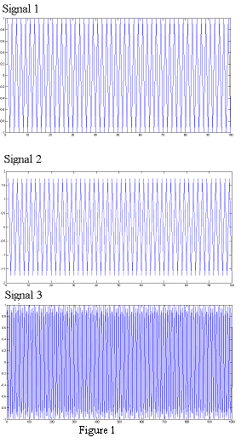
We evaluated the FastICA algorithm, using the M-Estimators as the cost function, and use 3 zero-mean non-gaussian signals, given in figure 1 on MATLAB. We also compared the convergence of the M-Estimator functions for speech signals, obtained from http://research.ics.tkk.fi/ica/cocktail/cocktail_en.cgi., along with the 2 ‘original’ non-linearites ,i.e. tanh and pow3 .
The mixing matrix, A, is randomized, as could be the case in real world scenarios. An additional gaussian noise was added to the recorded signals.

As specified in [7], there may not be a single tuning constant value which could be used to easily separate the observed signals for the M-Estimators. The only problem which may be observed for all the M-Estimators is that there may be a slight difference of number of iterations for convergence, if any. As per our analysis of the different signals, we found that Cauchy’s M-Estimator converged when c_{k}ε (0.06,0.17)U(0.225,2.05) while Welsch converged when c_{w} ε (0.23,0.3)U(1.9,1.15). Huber converged for all values of k_{huber} ε (0,2] Please do note that all the three M-Estimators, i.e. Cauchy, Welsch and Huber, depended heavily on the mixture of the Gaussian noise with the p.d.f of the function. This was determined experimentally by executing the three M-Estimators on the speech signal, as well as on the zero – mean signal, for the same initial weight matrix and gaussian noise, but for different values of tuning parameters. It was found that there was no difference in the number of iterations for c_{k} , c_{w} and k_{huber.}
The FastICA Algorithm was executed 100 times on the 3 zero-mean signals to determine a consistent average. The observed signal had samples N=1000-10000, with each iteration separated by 500.

The observations for the above execution are recorded in Table 1 below:

The FastICA algorithm with M-Estimators as its cost function was also evaluated on the speech signals, as real life samples were not studied in [7].
The observations of the speech signals have been reported in table 2.
As per the observations in Tables 1 and 2, we could conclude that all the M-Estimators are very sensitive to the p.d.f of the source signal, as well as the gaussian noise which has been added to the signal. Welsch, with c_{w} ε (1.9,1.15) and Geman-Mclure are not very ideal choice for non-linearities for FastICA, as they tend to fail to converge for large number of samples. The same observation can be said for Cauchy with c_{k}ε (0.225,2.05). However, Cauchy and Welsch perform better for both real-life and zero-mean non-gaussian signals when c_{k}ε (0.06, 0.17) and c_{w} ε(0.23,0.3), though not too well when compared with the performance of tanh and pow3.
To be noted is the performance of Huber, for both cases considered. Though Huber fails to converge initially for a small sample set, it should be noted that the Huber converges effectively and also faster than tanh and pow3 in most occasions. Huber also performance very well when the separation performance between tanh, pow3 and Huber is considered
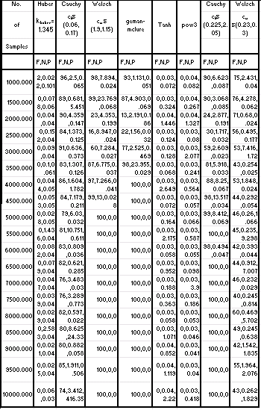
Table 1: Comparison of the various non-linearities in FastICA. F stands for Failure to
converge in 100 iterations; N is the average number of iterations for convergence
(0 if no convergence);P is the separation performance given in [7]

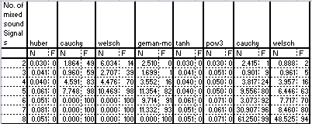

Table 2: Comparison of various non linearities in FastICA. F and N have the same definition as above

4. CONCLUSION
FastICA depends not only on the cost function to compute the independent signals; it also takes into consideration the p.d.f of the source, as mentioned in [2]. Since any non-quadratic function can be used for FastICA, therefore, in this paper, the idea of using Cauchy, Welsch, Huber and Geman-Mclure, and their performance for different signals was compared, along with tanh and pow3 cost functions. It was determined that all M-Estimators are sensitive to the p.d.f of the source, and while Cauchy, Welsch and Geman-Mclure may not be very effective, Huber performed exceptionally well in most situations. Additionally it was also found that the tuning constants do not affect Cauchy, Welsch and Huber, as the number of iterations for convergence is almost the same for the same observed signal set.
5. REFERENCES
[1]Hyvarinen A. “Independent Component Analysis: Algorithms and Applications”. Neural Networks, 2000, 13:411-43
[2] Hyvarinen A.,”Fast and Robust Fixed-Point Algorithms for Independent Component Analysis”, Neural Networks, April 23,1999
[3] Hyvarinen, A., Karhunen, J., Oja, E.: Independent Component Analysis. John Wiley & Sons, New York (2001)
[4] Scott C. Douglas, Malay Gupta,Hiroshi Sawada, and Shoji Makino“Spatio–Temporal FastICA Algorithms for the Blind Separation of Convolutive Mixtures “ IEEE transactions on Audio,Speech,and Language Processing, Vol. 15, No.5, July 2007
[5]Malaya K. Nath”Independent Component Analysis of Real Data “2009 Seventh International Conference on Advances in Pattern Recognition
[6]In Jae Myung,Tutorial on Maximum Likelihood Estimation,Journal of Mathematical Psychology, October 2002
[7] Chao,Jih-Cheng and Douglas,Scott C.,”A Simple and Robust FastICA Algorithm using the Huber M-Estimator Cost Function”,ICASSP,2006
[8] Zahooruddin,Farooq Alam Orakzai,"Hardware implementation of blind source separation of speech signals using independent component analysis",International Journal of Electrical & Computer Sciences IJECS-IJENS Vol: 10 No: 01
[10] Zhengyou Zhang, Parameter Estimation Techniques:A Tutorial with Application to Conic Fitting,Image and Vision Computing, Vol.15, No.1, pages 59-76, January 1997.

